**REST - Get country based on country code** 

**Step 1:**

Create a Maven project using <https://start.spring.io/> along with the dependency spring web tools.

**Step 2:**

Create a folder called model in src \ main \ java \ com \ cognizant \ spring-learn1 and create a file called Country.java and write the following code

package com.cognizant.spring_learn1.model;

public class Country {

private String code;

private String name;

public Country() {}

public Country(String code, String name) {

this.code = code;

this.name = name;

}

public String getCode() {

return code;

}

public void setCode(String code) {

this.code = code;

}

public String getName() {

return name;

}

public void setName(String name) {

this.name = name;

}

}

**Step 3:**

Create a service folder in your src \ main \ java \ com \ cognizant \ spring-learn1 and create the file CountryService.java and write the following code:

package com.cognizant.spring_learn1.service;

import com.cognizant.spring_learn1.model.Country;

import org.springframework.context.ApplicationContext;

import org.springframework.context.support.ClassPathXmlApplicationContext;

import org.springframework.stereotype.Service;

import java.util.List;

@Service

public class CountryService {

public Country getCountry(String code) {

ApplicationContext context = new ClassPathXmlApplicationContext("country.xml");

List<Country> countries = (List<Country>) context.getBean("countryList");

return countries.stream()

.filter(country -> country.getCode().equalsIgnoreCase(code))

.findFirst()

.orElse(null);

}

}

**Step 4:**

In the controller folder update the CountryController.java as follows

package com.cognizant.spring_learn1.controller;

import com.cognizant.spring_learn1.model.Country;

import com.cognizant.spring_learn1.service.CountryService;

import org.slf4j.Logger;

import org.slf4j.LoggerFactory;

import org.springframework.beans.factory.annotation.Autowired;

import org.springframework.web.bind.annotation.*;

@RestController

public class CountryController {

private static final Logger LOGGER = LoggerFactory.getLogger(CountryController.class);

@Autowired

private CountryService countryService;

@GetMapping("/country/{code}")

public Country getCountry(@PathVariable String code) {

LOGGER.info("START");

Country country = countryService.getCountry(code);

LOGGER.info("END");

return country;

}

}

**Step 4:**

Create the country.xml in the src \ main \ resources as follows

<?xml version="1.0" encoding="UTF-8"?>

<beans xmlns="http://www.springframework.org/schema/beans"

xmlns:xsi="http://www.w3.org/2001/XMLSchema-instance"

xmlns:util="http://www.springframework.org/schema/util"

xsi:schemaLocation="

http://www.springframework.org/schema/beans

https://www.springframework.org/schema/beans/spring-beans.xsd

http://www.springframework.org/schema/util

https://www.springframework.org/schema/util/spring-util.xsd">

<bean id="in" class="com.cognizant.spring_learn1.model.Country">

<property name="code" value="IN"/>

<property name="name" value="India"/>

</bean>

<bean id="us" class="com.cognizant.spring_learn1.model.Country">

<property name="code" value="US"/>

<property name="name" value="United States"/>

</bean>

<bean id="uk" class="com.cognizant.spring_learn1.model.Country">

<property name="code" value="UK"/>

<property name="name" value="United Kingdom"/>

</bean>

<util:list id="countryList">

<ref bean="in"/>

<ref bean="us"/>

</util:list>

</beans>

**Output:**

Run the java application

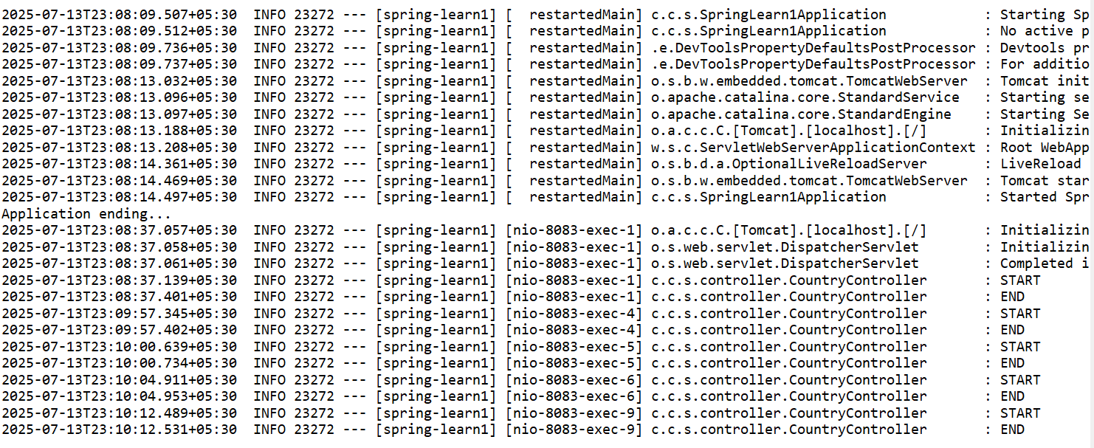

Open the browser and run the URL <http://localhost:8083/country/US> to get

